

For Fresh Super Market

Project Documentation of Point-of-Sale Solution

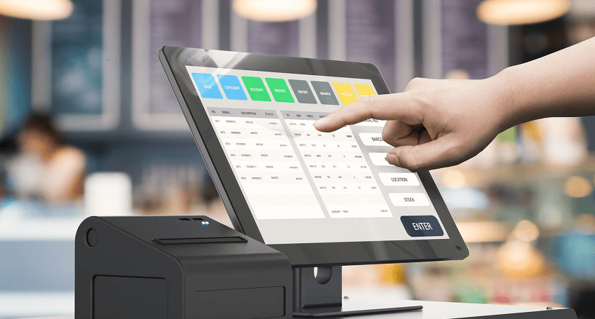

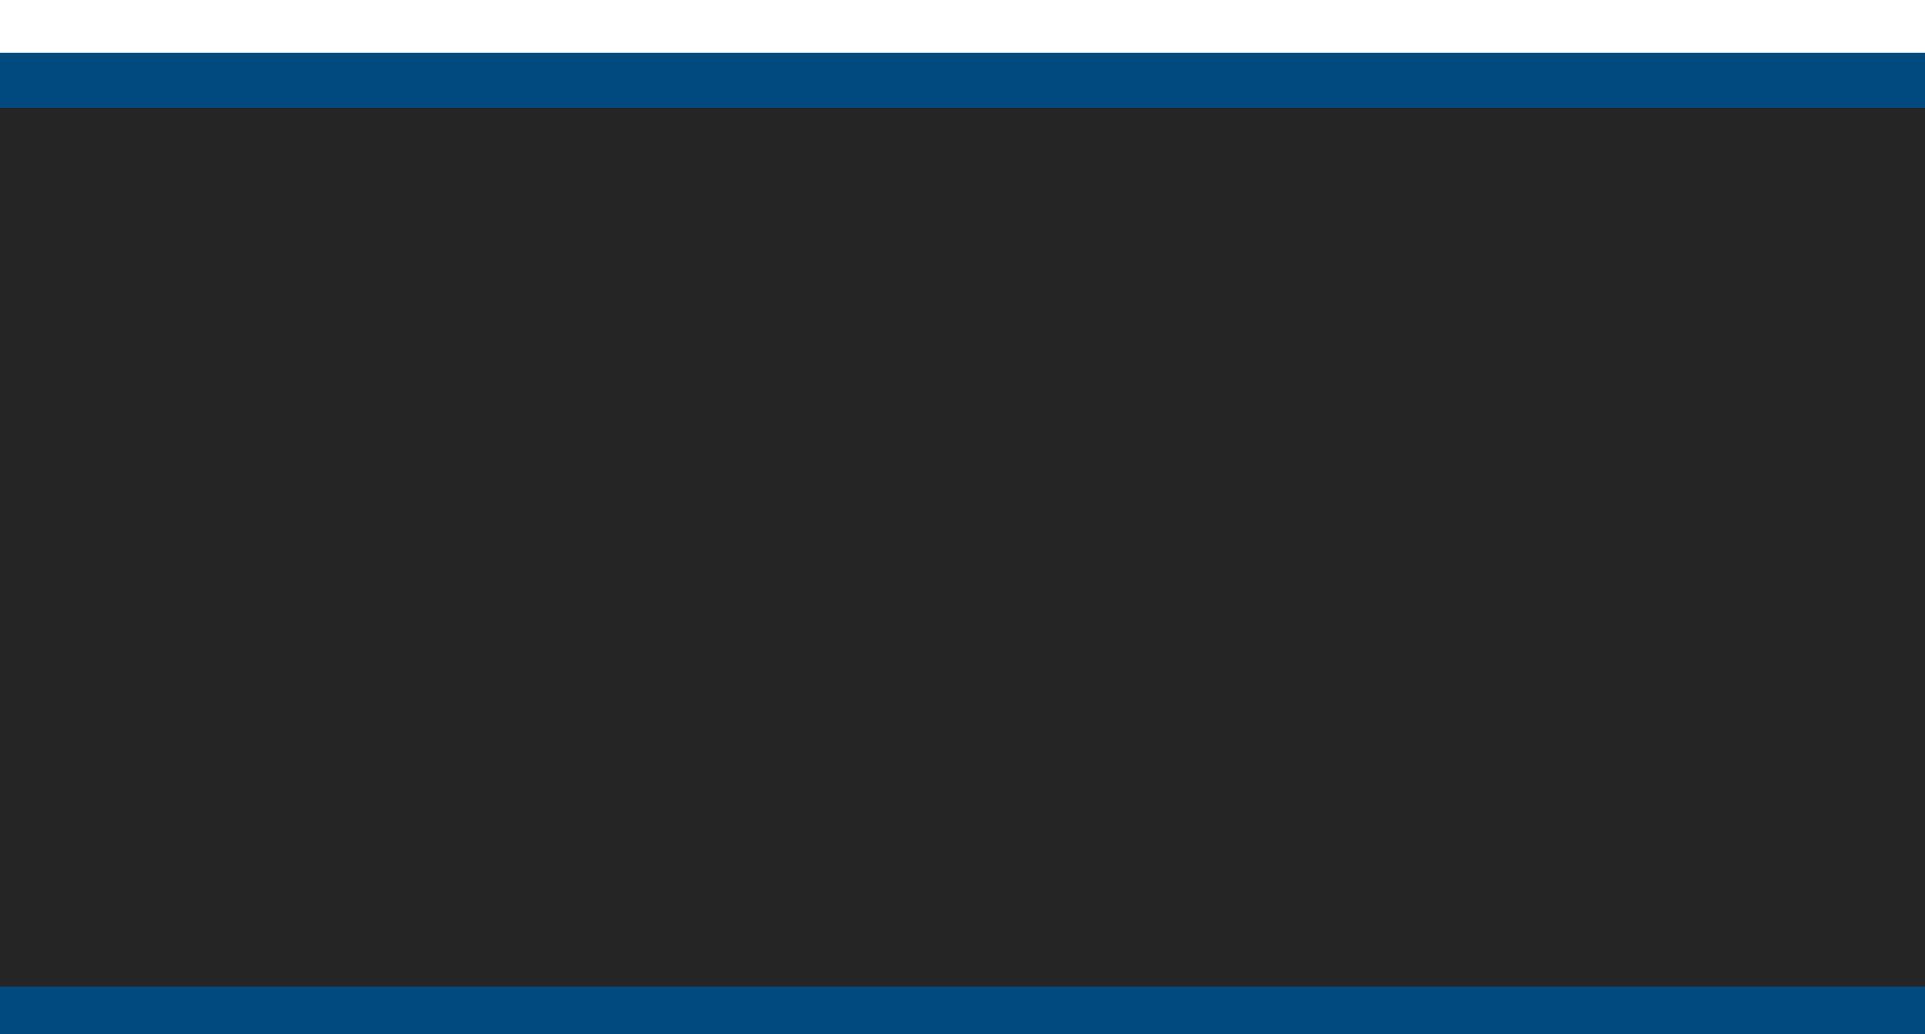



Asela Niroshan Dharmadasa,

ATN Campus.

LC000206000001

ATN-CN-T01-20102

# Table of Content

Contents

Table of Content 2

Acknowledgement 5

Executive Summary 5

Motivation 5

Project Description 6

1. Background / Literature Review 6

I. Background and Current Situation 6

II. Point of Sale Solution 7

III. Point Of Sales Solutions available in the Market 8

2. Overall Purpose/objective of the Project 12

System Analysis 13

1) Requirement Gathering and Fact Finding through Interviews 14

2) Requirement Analysis 15

1. Functional Requirements 16

2. Non – Functional Requirements 17

I. User friendliness of the Interface 17

II. Performance 17

III. Security 17

IV. Availability 17

V. Privacy 17

3) Requirement Analysis 17

1. Proposed System simple Work Flow 18

I. Sell Items 18

II. Buy items from Suppliers 18

2. Point of Sales Operations 19

III. Users and Roles 20

System Design 22

1) Diagrams 23

1. Use Case Diagram 23

2. Activity Diagram 24

25

Database Design 26

3. ER Diagram 27

2. Database Diagram 28

System Design 29

1. MVC Architecture 30

2. Class diagram 31

3. Use Case Design 32

I. Pos Operations 32

II. Daily Sales of a Cashier 36

III. Daily Sales of the Super Market 37

4. Admin Operations 38

I. Product Item Operations 38

II. Product Category Operations 41

III. Employee Management 43

IV. Discount Promotions 45

V. Popular Items 47

VI. Supplier Management 48

Tools that used to Development 50

1) Programming Language 51

2) Database Management 53

3) User Interface 55

4) Other tools Used 55

User Interface Design 56

1. Login Interface 57

2. Cashier Panel 58

3. Admin Panel 59

4. Product Items 60

5. Product Category 61

6. Manage Cashiers 62

7. Promotional Discounts 63

8. Popular items 64

9. Supplier Management 65

10. Bill Issuing 66

Implementation 67

1) User Input Validation 68

2) Human Friendly Coding 69

3) IDE console as Log viewer 70

4) Encapsulation 71

5) Change Variable Types 72

Testing 73

1) Testing Methodology 74

2) White Box Testing 74

3) Black Box Testing 74

4) User Acceptance Testing 75

5) Usability Testing 75

6) Testing Login View 76

7) Testing POS Operations 77

8) Test Issuing Bill to Customers 78

9) Testing Product item view 79

10) Testing Product Category View 80

11) Testing Employee View 81

12) Testing Promotional Discount View 82

13) Testing Supplier View 83

Collecting Customer Feedback 84

1. User Acceptance 85

Future Upgrades 88

1) Security 89

2) Log viewers 89

3) Reports & Charts 89

What I Have Learnt 90

# Acknowledgement

In completing Fresh Super market Point of sale Solution, I had to seek for help and guidelines from a respected person, who deserve my greatest appreciation and gratitude. The completion of this project gives me much pleasure. First of all, I would like to offer my biggest gratitude to my lecturer, who teach me and guide me in the System Analysis and Design subject Eng. DB Wijesinghe, for giving me a good guideline and countless consultations.

# Executive **Summary**

This Point-of-Sale Solution has developed for a small range supermarket to perform their Point of Sales Operations. And also, system supplies Inventory Management system, Consumers and Suppliers Management System with Multi User Experience in Networked Environment.

# Motivation

Point of sales operations of the ‘Fresh Super market’ organization is not handled properly. They are using an excel sheets to maintain Sales related information. Therefore, they need a new system which can handle all the Point of sales operations related tasks to do in lest time and lest effort. Some of the feathers include in the system are display Sales reports according to any given month and year, top selling product items, and keeping track of all the point of sales operations details, simple inventory management. By developing software which can handle these tasks can make it easy to keep track of information in a centralized system. In the current system there is not a proper way to identifying POS related information for customers according to the month, year separately. And also, it does not display daily sales by individuals and for all employees. This new system will display Sales Operations information in a detailed and easy way.

Sales details of all the employees can be viewed in a single page for any selected year and month. so, it will be a very attractive thing to the cashiers and top-level users as well. They can simply get an idea of the sale details and data by looking a one single interface which will be an interesting thing. Users of the system can easily add new product items, suppliers, employees to the system. Salary slip generation is very easy and can be done according to the employee.

# Project Description

## Background / Literature Review

### Background and Current Situation

Fresh Super Market use manual systems to perform their sales and inventory. When customer selects their buying items to a cart, he can check out at the cashier. Cashier creates a bill after checking the items, quantity and their price manually. Then calculate the total with calculator and issues a bill with mentioning total due paid amount. Then customer paid the amount and cashier has to check whether is there any balance to pay to the customer back is. They ware using Microsoft excel and Manual Book keeping Methods to handle their daily operations.

So, Cashier, manager or owner hasn’t any idea about sales of the day until add the total bill amounts of the day. And until then they haven’t any idea about amount of money they have in the cashier. So, they have to do lot of manual calculations to identify daily sales as well as weekly monthly and annually.

If consumer asks about certain product, any one hasn’t idea about product, how many amounts of product is still their inventory. So, they have to go physically or search on books and check whether item is available or not. And also, if the item unavailable they have to check the books for find details of the supplier.

After applying Software solution expected to automate lot of process and procedures and improves and enhanced the productivity of the entire Supermarket. Issuing bills and receipt via proposed system, Real time inventory and supplier management system are expected to implement.

So, at first this Point-of-sale solution is developed for a small range Supermarket called Fresh Super market to automate their Point-of-sale records and analyze their business easily.

### Point of Sale Solution

A Point-of-sale System used to perform Point of sales operations and other supportive task. And it will improve the productivity of an organization. So Usual Point of sale Systems Performs

* + 1. Ordinary Point of sales Operations
    2. Assign and update product price
    3. Declare discounts
    4. Inventory Operations (usually simple operations only)
    5. Billing and reporting
    6. User Handling (Cashiers, Mangers, Admins)

Point of Sale in the sense of "Sale product and get Paid" plays a major role in a company for several reasons.

From an accounting perspective, POS is crucial because POS operations and its relative operations are considerably affecting the net income of a Supermarket. because they must obey to laws and regulations regarding consumer rights. From a human resources viewpoint, the POS is critical because consumers are sensitive to price of a product. It must be not higher than standard price and lot of products must be sell or remove from sale before their Expire date. And helping Higher level employees to get an idea regarding bestselling items and each items enough for how many days will be an advantage.

When increase the count of consumer in same time, Company must have a system to not let them late to leave after they bought required items. In Currently lot of people consider that “Time is Money”. So, nobody likes to be late. Therefore, Super market must have a proper plan to, how let to do shopping and how to manage them without late. POS System Can act a major role for this incident, because it has a capability to reduce the time to check out.

### Point Of Sales Solutions available in the Market

**Toast POS**

Toast POS was developed by Toast, Inc., a cloud-based. the software was launched in 2012 and has grown into one of the most popular POS programs designed for restaurant operations today. This software is designed to assist guests, employees, and managers in the food and beverage industry.

Users can access the mobile POS system anywhere and anytime, as long as there is an internet connection. The key components of a guest experience management are implemented in one place, allowing you to focus on caring for your guests. The program also includes online ordering, staff reporting and sales, and gift cards and loyalty programs. You can sign up for a free Toast POS demo to determine if the software matches the workflow.

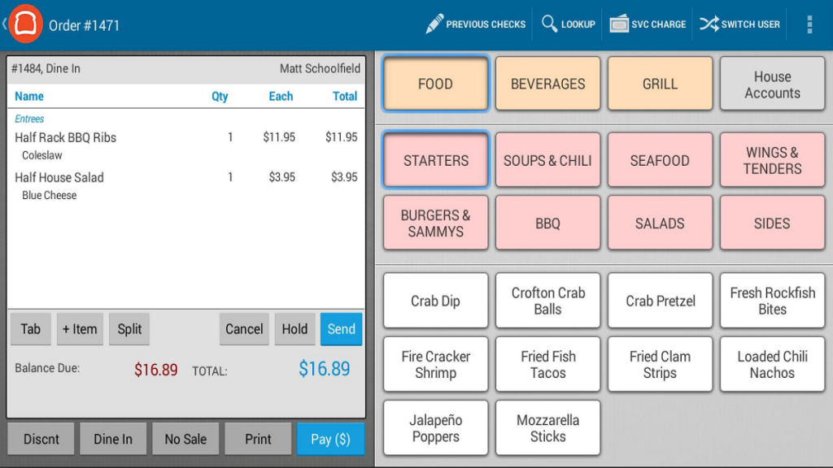

**Lightspeed**

Lightspeed is an ecommerce software provider and point of sale. Its headquarters are located in Canada. It has four main products:

Lightspeed Retail POS

Lightspeed eCommerce

Lightspeed Restaurant POS

Lightspeed Onsite

With this, users can choose a cloud-based solution that has features tailored to their specific business needs depending on their industry.

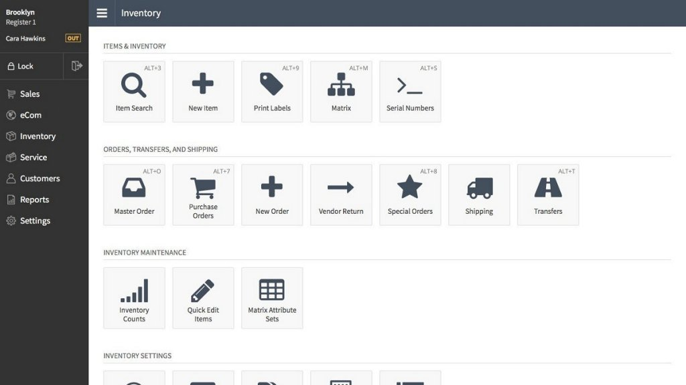

**Revel Systems POS**

From Revel Systems, Inc. comes an intuitive iPad-based point-of-sale solution for merchants of all sizes, Revel Systems POS. It’s equipped with all the functions necessary for making businesses’ day-to-day operations easier and more efficient. The POS system is paired with other tools such as employee, inventory, and sales management. It also provides helpful insights through its reporting and analytics features. This ensures that you know which items to stock the most and which are gathering dust in the corner shelf.

can use all the features for free for a period of time to see if the software matches your needs.

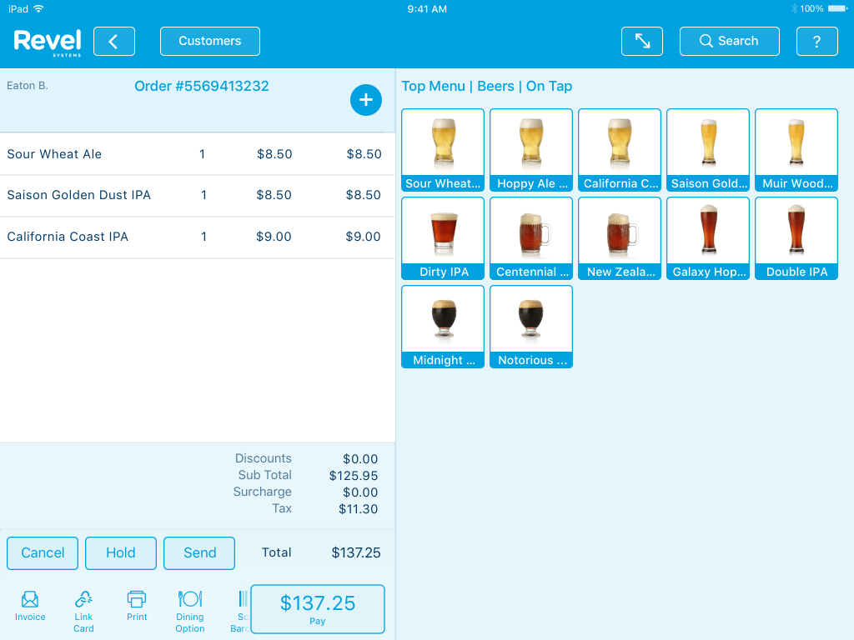

**Quiсk Bооks РОS**

QuickBooks POS is a powerful platform that enables users to track sales, customers and inventory efficiently and quickly. Available in two versions, Basic and Pro, QuickBooks Point of Sale is designed to strengthen business customer service and meet their needs. It tracks customer information and comes with a variety of features to keep customer loyalty and retention enhanced and encourage recurring sales. These features include tracking their previous purchases so you know what brands and products they choose to buy.

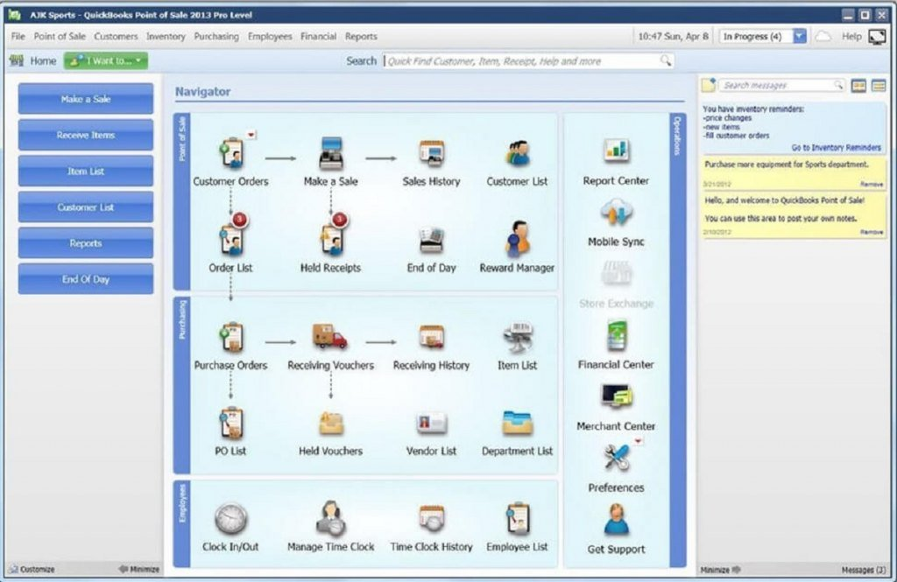

## Overall Purpose/objective of the Project

After implementation this project at the Mini Supermarket, deliver Fast customer support is guaranteed and required sales assistant amount will be reduced and their workload also will be reduced.

We are proposing to implement the system to change workflow as follows.

When customer came to the supermarket we give the freedom to them, walk across the super market for choose what they want, instead ask what they need form sales assistants. So, Customer who has a shopping cart at the hand will buy more than just asking the product because of the freedom and built-up buy more attitudes in the super market. So, Customer will not hesitate to ask the price from sales assistant, they can check the products attribute and choose what they want. Thus, Customer satisfaction will be high and can be expected more percentage of customer base as regular customer.

Since Customer chooses what they want, just there are few sales assistant is required for help to find out where the item located and for measurable products.

When Customer select products, they want and they can come to cashier. Since All Products details are entered to the system cashier can identify the products which customer bought by  
 scanning Barcode labeled on the Item

Searching Product ID

Searching item name

Enter Custom product with Custom price

So, no need to ask the price and manual calculation because implemented system will be doing that and generate a bill.

So, when certain cashier off the duty they can get a summary of sales and how many cash at the cashier. It’s making easy to shift changes of cashiers. And also End of the day, week and month as wells as annually managers can generate report about sales products wise or category wise.

When Supplier came to the supermarket manager or owner can get inventory details filter item wise or which and which products supplier usually supply. So they can decide faster whether certain product must me buy or not.

# System Analysis

# Requirement Gathering and Fact Finding through Interviews

Before the System analysis parts, it has to gather requirements. Since POS system developed for enhanced existing procedure, better to get present situation of their super market from employees. They have a better idea about the current situation and may have concepts to enhanced the workflows.

So best way to collect their ideas is doing interviews with them in off peak hours of the super market. And also used a questionnaire to collect their responses will be the best way

**Questionnaire**

1. Name
2. Designation
3. Have you any IT related Experience?
4. How do your Supermarket process are handling now? (Please describe what happens, where happens, who involves, Challenges During the Process)
   1. Selects items by Customers
   2. Billing
   3. Inventory Management
   4. Purchasing
   5. Shift Changes Cashiers
   6. Supplier Management
   7. Reporting
5. Any Idea to enhance above process as they think?
6. Usually How many Customers in the supermarket at a time?
7. Usually How many Customers in the supermarket at its busiest time?
8. Usually how many Customers came to the supermarket in a Day?
9. How many minutes take to prepare a bill and accept cash?
10. How many minutes spent at the queue by customer usually and busiest time?
11. Please Describe the Procedure when returning an item.
12. Please Describe the Procedure to purchase items From Supplies.

# Requirement Analysis

Analysis is based on requirement gathering, functional requirements and non-functional requirements. First have to gather required information from the client prior to implementation of the system. Need to have good understanding of the requirements of the users of the system.

And also required information is done by referring the internet and find out similar solutions and get some ideas from that as well. And also, had meet ups with the client and by doing so able to gather lot of information like how should be the interfaces looks like and what are the main and sub functionalities they are looking for and what type of users may use the system and their computer knowledge and understanding of the system also identified.

The Requirements can be mainly divided into two parts which are

• Functional Requirements

• Non-Functional Requirements

Functional requirements include the actual systematic functions of the system which is directly expecting by the client to be get from the system using user interfaces. This covers the general requirements which can see directly.

Non-Functional requirements include the functions which are not directly visible and which should include in the system to be a more valuable and good system. These requirements are also expected by client and very important to get the client satisfactory. These can be measured using different technologies and they are depending on the functionality type.

## Functional Requirements

1. System must be help to choose customer bought items to add to the bill without any delay
2. Cashier must see available quantity and prices of each item in the super markets when doing POS operations.
3. Before start the entering data, cashier must create a bill and it must be assigned to the name of customer. (Default customers also available)
4. After adding items System must generate a printed bill.
5. System must be display selected items, quantity, each price and subtotal amount (each price * Qty) When adding items and must be shows Current total amount of the bill.
6. When change the Quantity after adding item system must be auto updated to the bill amount subtotal and discount.
7. When add before added items to the same bill, (customer has choose multiple items from each item) bill must not create another row, it must update previous item record by updating current quantity.
8. System must be capable to handle several bills simultaneously
9. After adding items final total must be displayed in pole display too and bill must be printed.
10. There are several types of users to perform on the system and system must configured to access functionalities according to the user privileges.
11. End of the day each user can get sale summary report and other required reports according to their privileges

## Non – Functional Requirements

### User friendliness of the Interface

User is able perform POS operations within single interface easily. So, user can view all the allowed panels in a single interface. And also, admin and managers can view the reports according to the year and month in a single interface. Interfaces are clear and easy to identify because of the look and appearance of them. It is not complex and colors and themes will be attractive for the person using the system.

### Performance

User will able to view the details quickly without any delay. Data should be loaded instantly to the user when perform a task in the system.

### Security

Security also very important factor in system and the whole system is therefore password protected. Main interface of the system can be only accessed after provide the main password. Other than to view reports and to done a restoration of a database separate passwords are needs which ensures the security of the system.

### Availability

System should available for the use whenever it needed to access. Since this is desktop application availability should be always there without even having the network support. Connection to the database should be there always and hence able to do any insertion or updating to the database without any issue.

### Privacy

All employee related details only can be update and access by authorized person. Database access should be only done using authorized person and database should have a password and only admin users should able to use that.

# Requirement Analysis

## Proposed System simple Work Flow

### Sell Items

1. *Customer Selects items by reaching to the item*
2. *After Selecting item customer will be at a Cashier*
3. *Cashier Enters items to the System*
4. *System Shows Subtotal and Current bill amount when cashier add items to the system*
5. *After adding items System displays the total bill amount*
6. *After adding items, Pole display shows the final amount and Cashier says to the customer*
7. *Cashier select the payment method by asking the customer*
8. *Cashier Enter the cash amount and give back the balance amount if available or process the Card payment System.*
9. *System Generate the Bill*
10. *When Cashier Marked as Paid System will updated and ready to serve another customer*

### Buy items from Suppliers

1. *Supplier comes to the manager*
2. *Manager find the Supplier from the system*
3. *System Shows items which supplier usually supply and its stock limit*
4. *If manager bought items, manager can enter records and update System*
5. *System will generate an invoice.*

## Point of Sales Operations

Point of sales operations starts at cashier. Customer choose items and add those to cart and will come to the cashier. Then cashier start to perform POS operation

1. System must be help to choose customer bought items to add to the bill

Initially System will be displays available items at the supermarket in a left side panel. Cashier can view by scrolling and select by double tapping the item to add to current bill. cashier can use also below options to add products to the bill,  
i. scanning the barcode which labeled on the product

ii. entering the product barcode to the system,   
iii. Searching item by name or price

1. Cashier can see available quantity and prices of each item in the super markets.
2. Before start the entering data, cashier must create a bill and it must be assigned to the name of customer. (Default customers also available)
3. Bill has several states as follows
   1. Created - customer came to the cashier and ready to add items
   2. Processing - adding items
   3. Hold - customer choosing additional products
   4. Bill generated - bill has printed
   5. Paid - end adding items and paid total amount
   6. Queue - queue to the deliver to customer if requested
   7. Sent - sent items to customer
   8. Delivered - Delivered items
4. System must be display selected items, quantity, each price and subtotal amount (each price * Qty) When adding items and must be shows Current total amount of the bill.
5. When change the Quantity after adding item system must be auto updated to the bill amount subtotal and discount.
6. When add before added items to the same bill, (customer has choose multiple items from each item) bill must not create another row, it must update previous item record by updating current quantity.
7. System must be capable to handle another bill without completing current bill processing. (If customer decided to add more items to the bill, cashier and next customer must not wait until the current customer come. Cashier can hold the current bill and serve the next customer. When customer comes with new items cahier can resume previous billing operation).
8. After adding items final total must be displayed in pole display too and bill must be printed.
9. Bill must have
   1. Supermarket name and contact details
   2. Date and Time
   3. Barcode (product id)
   4. Item name
   5. Quantity
   6. Each price
   7. Discounts
   8. Subtotal
   9. Total price
   10. Discount for the total bill
   11. Payable
   12. Paid type
   13. Paid amount
   14. Balance
   15. Return policy notice
10. Cashier can see today sales by cash, cards and total separately.
11. When Cashier off the duty he can obtain a printed copy of daily sales he has done and available cash amount in the drawer.

### Users and Roles

1. There are three User types and each type has to play different roles. And also, they have different facilities to manage the System.
   1. Cashier
      1. perform POS operations
      2. Check Daily Operations done by him self
      3. Check his drawer cash balance
      4. Check each item count within store

* 1. Manager
     1. Perform POS operations
     2. Check daily operations of each cahier and total
     3. Check drawer cash balance and operations for each user
     4. Edit a bill (remove items from bill)
     5. Check each Item Count
     6. Update item count and its price
     7. Declare Discounts for each product, product category and to the total bill according to bill value
     8. Create, edit, remove cashier users
     9. Generate Daily Monthly and Annually Sales report
     10. Generate cashier daily Business summary
     11. Check Popular products,
     12. Predict sufficient days for each item by calculation daily sales and seasonal sales (December, April)
     13. Show Warning When item count gets low
  2. Administrator
     1. Perform all the manager Operations
     2. Perform Database Backup and restore
     3. Create, edit, delete Manager Users

So, user can perform their intended task according to their privileges.

# System Design

# Diagrams

## Use Case Diagram

## Activity Diagram

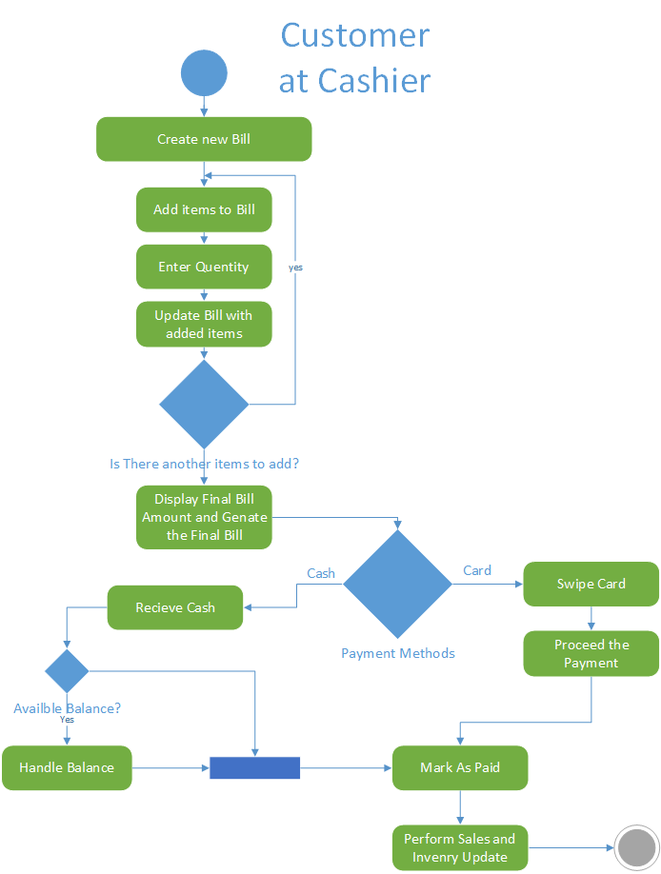

## 

# 

# Database Design

## ER Diagram

## Database Diagram

# System Design

## MVC Architecture

Model view Architecture has used to planning and designing the System. So can See Three Different Folder have called model, view and controller.

In view package contains all the user interfaces designed in JavaFX framework as .FXML files.

In the Model package has created java classes for store database data when retrieved and before execute database CRUD operation.

In Controller package contains all the controlling instructions such as connect the database, retrieve data to the data model from data source.

So, User can request particular operation through a user interface and it will be handled by the desired controller. The controller performs operations and used required models to perform database operations

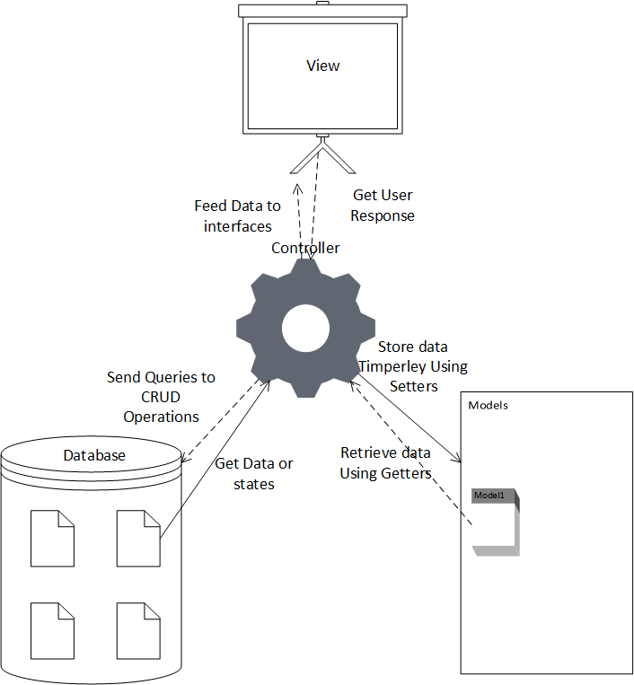

## Class diagram

## Use Case Design

### Pos Operations

|  |  |  |
| --- | --- | --- |
| **01** | **Use-Case ID** | 001 |
| **02** | **Use Case Name** | Create New Bill |
| **03** | **Actor** | Cashier / Manager / Admin |
| **04** | **Pre-Condition** | 1. Cashier privileged user must be logged in 2. Sales items must be loaded in to item table |
| **05** | **Main Flow** | 1. All uncompleted Previous Bill’s state change to hold 2. Create New Bill (Bill State: new) 3. Get the next Bill number 4. Select the Customer name if exist *(Bill State: Processing) |
| **06** | **Alternative Flows** | 1. If Customer name does not present in the Customer list, then create a new Customer or assign demo Customer. |
| **07** | **Post Condition** | 1. Previous bill amounts and data must be cleared 2. System must be ready to get items as input to the bill |

|  |  |  |
| --- | --- | --- |
| **01** | **Use-Case ID** | 002 |
| **02** | **Use Case Name** | Add items to the bill |
| **03** | **Actor** | Cashier/Manager/Admin |
| **04** | **Pre-Condition** | 1. Cashier privileged user must be logged in 2. Sales items must be loaded in to item table 3. Created new bill or uncompleted bill must be available to add items (bill state: processing) |
| **05** | **Main Flow** | 1. Select items from item table to the bill by  a. barcode Scanning   b. Name Search  c. Select items from Item Table   1. Prompt dialog box and ask bought quantity 2. Product id(barcode), name, each price must be received 3. Reduce Available discounts and calculate the total price for the item 4. Product id(barcode), name, qty, each price, discount and total value are displayed at the sale table 5. Update the total bill amount |
| **06** | **Alternative Flows** | 1. If customer needs to remove item from cart, it can be deleted. 2. If Customer needs to change quantity, it can be updated |
| **07** | **Post Condition** | 1. All of bought items must be in the bill table 2. Barcode, item name qty, discount and price must be displayed for each row 3. Total bill amount and discount amount must be displayed |

|  |  |  |
| --- | --- | --- |
| **01** | **Use-Case ID** | 003 |
| **02** | **Use Case Name** | Processing Payments |
| **03** | **Actor** | Cashier/Manager/Admin |
| **04** | **Pre-Condition** | 1. Cashier privileged user must be logged in 2. Bought items must be displayed in to sale table 3. Total bill amount, discount amount and payable amount must be displayed. |
| **05** | **Main Flow** | 1. Cashier asked the payment method by customer 2. If payment method is Card payment, cashier asked customer credit/ Debit card and swipe at the payment gateway device. 3. Process the Payment 4. When Succeeded, Cashier Press the Paid and Print the Bill (Bill State: paid) 5. After Sales Database Update Process must be started |
| **06** | **Alternative Flows** | 1. If customer ready to pay with cash Cashier receive cash and enter the received amount to the System and press Enter Key 2. System Shows Balance Amount 3. If balance amount has to pay, Cashier settle the Balance 4. Cashier Press the Paid and Print the Bill (Bill State: paid) 5. After Sales Database Update Process must be started |
| **07** | **Post Condition** | 1. Bill have printed with customer bought items including their price, discounts and total amount, payable amount, balance, and bill number, customer name and date time as well. 2. Bill States has changed to paid |

|  |  |  |
| --- | --- | --- |
| **01** | **Use-Case ID** | 004 |
| **02** | **Use Case Name** | Database Update after Sale |
| **03** | **Actor** | Cashier/Manager/Admin |
| **04** | **Pre-Condition** | 1. Every Post Conditions of use Case called Processing Payments must be fulfilled. (   Bill have printed with customer bought items including their price, discounts and total amount, payable amount, balance, and bill number, customer name and date time as well.  Bill States has changed to paid  ) |
| **05** | **Main Flow** | 1. Update the Bill Table with Bill details 2. Update the Bill item table with bought items relevant to the current bill. 3. Update Product items Table, reducing sales item count of each Product items by available product counts for update Current inventory Count. 4. Bill States Changed to closed |
| **06** | **Alternative Flows** | N/A |
| **07** | **Post Condition** | 1. Product item Table 2. Bill Table 3. Bill Item Table Must be updated according to the processed Bill |

### Daily Sales of a Cashier

|  |  |  |
| --- | --- | --- |
| **01** | **Use-Case ID** | 005 |
| **02** | **Use Case Name** | Daily Sale of a Cashier |
| **03** | **Actor** | Cashier/Manager/Admin |
| **04** | **Pre-Condition** | 1. Cashier privileged or higher-level user must be logged in |
| **05** | **Main Flow** | 1. Cashier Can See Own Sales Report by Clicking Daily Sales Button 2. Daily sales report Has Cashier id, Name, Date and Daily Sales Amount 3. Daily Sales amount will be displayed separately as Cash payments and Card Payments 4. Cashier Get a Print of report and make a sign and hand over to the Manger. 5. Manager Check Cash and today processed payments according to reference number of the Gateway Terminal (if available feature within Bank) 6. Manager Check the Cash Balance of the Cashier Drawer 7. If above everything done without a problem Manager Sign the Report and give it back to the Cashier for off to the Day. |
| **06** | **Alternative Flows** | 1. Manager or Admin Can get the above-mentioned Report by Selecting relevant Cashier using the Cashier Daily Report feature at the Report Section |
| **07** | **Post Condition** | 1. May be Can have unpaid bills, so Report must be included only paid Bills Data. 2. Cashier can get Their own Daily Sales Report as above mentioned 3. Manager /Admin of Can get a Print of any of cashiers Daily Sales Report. |

### Daily Sales of the Super Market

|  |  |  |
| --- | --- | --- |
| **01** | **Use-Case ID** | 006 |
| **02** | **Use Case Name** | Daily Sale of the Supermarket |
| **03** | **Actor** | Manager/Admin |
| **04** | **Pre-Condition** | 1. Manager or Admin Privileged User must be signed in 2. All the Sales counter must be closed and end the sales for the day |
| **05** | **Main Flow** | 1. Manager or Administrator Perform Print Daily Reports 2. Following Reports will be Printed 3. Total Daily Sales 4. Daily Sales Cashier wise 5. Daily Sales Category Wise 6. Daily Top Sales Items 7. Items insufficient for next 7 days (according to past 7 days count) 8. Up to date Inventory |
| **06** | **Alternative Flows** | N/A |
| **07** | **Post Condition** | 1. All the report must be Printed Separately at once or one by one as user request |

## Admin Operations

### Product Item Operations

|  |  |  |
| --- | --- | --- |
| **01** | **Use-Case ID** | 007 |
| **02** | **Use Case Name** | Search Available Products |
| **03** | **Actor** | Manager/Admin |
| **04** | **Pre-Condition** | 1. Manager or Admin Privileged User must be signed in 2. All available Product items must be added and displayed in the Inventory table 3. Search by Barcode and Search by name text fields must be cleared |
| **05** | **Main Flow** | 1. Manager or Administrator Enter any part of barcode or product name in the relevant text field 2. Table will be filtered according to the text in text filed |
| **06** | **Alternative Flows** | 1. If Manager or administrator need to get details of a product which already in his hand, put cursor in the barcode text field and read the barcode via Barcode reader which connected to the computer. |
| **07** | **Post Condition** | 1. When Enter filter text to search by name or search by barcode text field or scan barcode product table must be filtered. 2. When above text fields Cleared, non-filtered table must be displayed |

|  |  |  |
| --- | --- | --- |
| **01** | **Use-Case ID** | 008 |
| **02** | **Use Case Name** | Ready to Add New Product Item |
| **03** | **Actor** | Manager/Admin |
| **04** | **Pre-Condition** | 1. Manager or Admin Privileged User must be signed in |
| **05** | **Main Flow** | 1. Privileged user presses the “New” Button 2. Load barcode automatically by checking product item table 3. Product category and product supplier combo box must be filled with available data 4. Date added text box will be filled with current day 5. Rest of all Text fields must be empty |
| **06** | **Alternative Flows** | 1. If couldn’t read the database prompt the error message |
| **07** | **Post Condition** | 1. Privileges user can add new item’s data to the relevant fields. |

|  |  |  |
| --- | --- | --- |
| **01** | **Use-Case ID** | 009 |
| **02** | **Use Case Name** | Add New Product Item |
| **03** | **Actor** | Manager/Admin |
| **04** | **Pre-Condition** | 1. Manager or Admin Privileged User must be signed in 2. All the requirements of Use case “Ready to Add New Product Item” must be fulfilled. |
| **05** | **Main Flow** | 1. Privileged user Enter product details 2. Then Press Add Button 3. Product item will be added 4. Confirmation Massage will be prompt |
| **06** | **Alternative Flows** | 1. Prompt error message, If required field empty or not in the required format |
| **07** | **Post Condition** | 1. New Product item will be added to the database |

|  |  |  |
| --- | --- | --- |
| **01** | **Use-Case ID** | 010 |
| **02** | **Use Case Name** | Update Product Item |
| **03** | **Actor** | Manager/Admin |
| **04** | **Pre-Condition** | 1. Manager or Admin Privileged User must be signed in 2. Products items must be loaded and displayed in product item table |
| **05** | **Main Flow** | 1. Select and double clicked the product item required to update 2. Product item details will be loaded to editable area 3. User Update the Data 4. Press the Update Button |
| **06** | **Alternative Flows** | 1. Prompt error message, if required field empty or not in the required format |
| **07** | **Post Condition** | 1. Relevant Product item will be updated |

|  |  |  |
| --- | --- | --- |
| **01** | **Use-Case ID** | 011 |
| **02** | **Use Case Name** | Delete Product Item |
| **03** | **Actor** | Manager/Admin |
| **04** | **Pre-Condition** | 1. Manager or Admin Privileged User must be signed in 2. Products items must be loaded and displayed in product item table |
| **05** | **Main Flow** | 1. Select and right clicked on the required item on the product item table 2. Select Delete from Drop down menu 3. Prompt a Dialog box to confirm 4. If Say Yes product item will be deleted |
| **06** | **Alternative Flows** | 1. Prompt Error message, if there is associated active discount promotion. 2. User has to remove all the associate discount promotions to delete a product item. (Prevent having orphan child records) |
| **07** | **Post Condition** | 1. Relevant Product item will no longer in the product item list |

### Product Category Operations

|  |  |  |
| --- | --- | --- |
| **01** | **Use-Case ID** | 012 |
| **02** | **Use Case Name** | Add Product Category |
| **03** | **Actor** | Manager/Admin |
| **04** | **Pre-Condition** | 1. Manager or Admin Privileged User must be signed in 2. Products categories must be loaded and displayed in product category table |
| **05** | **Main Flow** | 1. Press new Button to add new Category 2. Load category id Automatically by reading product category data table 3. Created date fields also updated 4. User will add a product category 5. Hit Add button |
| **06** | **Alternative Flows** | 1. Prompt Error message, if user entered duplicate Product Category |
| **07** | **Post Condition** | 1. Product category must be added |

|  |  |  |
| --- | --- | --- |
| **01** | **Use-Case ID** | 013 |
| **02** | **Use Case Name** | Update Product Category |
| **03** | **Actor** | Manager/Admin |
| **04** | **Pre-Condition** | 1. Manager or Admin Privileged User must be signed in 2. Products categories must be loaded and displayed in product category table |
| **05** | **Main Flow** | 1. Select the Required category row and double click 2. Product category data loaded in to editable area 3. Update the Category Name 4. Hit Update button |
| **06** | **Alternative Flows** | 1. Prompt Error message, if user entered duplicate Product Category |
| **07** | **Post Condition** | 1. Product category must be Updated |

|  |  |  |
| --- | --- | --- |
| **01** | **Use-Case ID** | 014 |
| **02** | **Use Case Name** | Delete Product Category |
| **03** | **Actor** | Manager/Admin |
| **04** | **Pre-Condition** | 1. Manager or Admin Privileged User must be signed in 2. Products categories must be loaded and displayed in product category table |
| **05** | **Main Flow** | 1. Select the Required item and right click 2. Select Delete from the Drop-down menu 3. Prompt Confirmation Dialog 4. If clicked Yes Delete item 5. Prompt if Success |
| **06** | **Alternative Flows** | 1. Prompt Error message, if there is associated product item. 2. User has to remove all the associate the product items or just remove association to delete a product category. (Prevent having orphan child records) |
| **07** | **Post Condition** | 1. Relevant Product item will no longer in the product item list |

|  |  |  |
| --- | --- | --- |
| **01** | **Use-Case ID** | 015 |
| **02** | **Use Case Name** | Add a new Employee |
| **03** | **Actor** | Manager/Admin |
| **04** | **Pre-Condition** | 1. Manager or Admin Privileged User must be signed in 2. Employee Details must be loaded and displayed in employee table |
| **05** | **Main Flow** | 1. Press new Button to add new Employee 2. Load employee id Automatically by reading employee data table 3. Created date field also updated to current date 4. User will add Employee Data 5. Then Hit Add button |
| **06** | **Alternative Flows** | 1. Prompt Error message, if user entered data is not in required format |
| **07** | **Post Condition** | 1. New employee Must be added to the system 2. New Employee Can log in to system and doing authorized operations |

### Employee Management

|  |  |  |
| --- | --- | --- |
| **01** | **Use-Case ID** | 016 |
| **02** | **Use Case Name** | Update Employee Data |
| **03** | **Actor** | Manager/Admin |
| **04** | **Pre-Condition** | 1. Manager or Admin Privileged User must be signed in 2. Employee Details must be loaded and displayed in employee table |
| **05** | **Main Flow** | 1. Select the Required user row from table and double click 2. Employee data loaded in to editable area 3. Update the Employee Data as required 4. Hit Update button |
| **06** | **Alternative Flows** | 1. Prompt Error message, if user entered data is not in required format |
| **07** | **Post Condition** | 1. Employee Data must be Updated |

|  |  |  |
| --- | --- | --- |
| **01** | **Use-Case ID** | 017 |
| **02** | **Use Case Name** | Delete Employee |
| **03** | **Actor** | Manager/Admin |
| **04** | **Pre-Condition** | 1. Manager or Admin Privileged User must be signed in 2. Products categories must be loaded and displayed in product category table |
| **05** | **Main Flow** | 1. Select the Required user data row and right click 2. Select Delete from the Drop-down menu 3. Prompt Confirmation Dialog 4. If clicked Yes Delete the User 5. Prompt if Success |
| **06** | **Alternative Flows** | 1. Prompt Error message, if there is associated product item. 2. User has to remove all the associate the product items or just remove association to delete a product category. (Prevent having orphan child records. So delete only newly assigned employee only)   Tip: Not Necessary to Remove employee who in out of Service. Just Update their state to disable. Then They can’t log any longer. |
| **07** | **Post Condition** | 1. New added employee Will be deleted |

### Discount Promotions

|  |  |  |
| --- | --- | --- |
| **01** | **Use-Case ID** | 018 |
| **02** | **Use Case Name** | Add a new Discount |
| **03** | **Actor** | Manager/Admin |
| **04** | **Pre-Condition** | 1. Manager or Admin Privileged User must be signed in 2. All available Discount data must be loaded and displayed in discount table 3. Load available products to product combo box to select |
| **05** | **Main Flow** | 1. Press new Button to add new Discount 2. Load discount id Automatically by reading discount data table 3. User Gives Accessible Name to Discount 4. User will select product and discount Percentage 5. Then Hit Add button |
| **06** | **Alternative Flows** | 1. Prompt Error message, if user entered multiple discounts for each product |
| **07** | **Post Condition** | 1. New Discount Must be added to the system 2. Discount must be calculated on POS |

|  |  |  |
| --- | --- | --- |
| **01** | **Use-Case ID** | 019 |
| **02** | **Use Case Name** | Update a Current Discount |
| **03** | **Actor** | Manager/Admin |
| **04** | **Pre-Condition** | 1. Manager or Admin Privileged User must be signed in 2. All available Discount data must be loaded and displayed in discount table 3. Load available products to product combo box to select |
| **05** | **Main Flow** | 1. Press new Button to add new Discount 2. Load discount id Automatically by reading discount data table 3. User Gives Accessible Name to Discount 4. User will select product and discount Percentage 5. Then Hit Add button |
| **06** | **Alternative Flows** | 1. Prompt Error message, if user entered multiple discounts for each product |
| **07** | **Post Condition** | 1. New Discount Must be added to the system 2. Discount must be calculated on POS |

|  |  |  |
| --- | --- | --- |
| **01** | **Use-Case ID** | 020 |
| **02** | **Use Case Name** | Remove Discount |
| **03** | **Actor** | Manager/Admin |
| **04** | **Pre-Condition** | 1. Manager or Admin Privileged User must be signed in 2. All available Discount data must be loaded and displayed in discount table |
| **05** | **Main Flow** | 1. Select the Required discount row and right click 2. Select Delete from the Drop-down menu 3. Prompt Confirmation Dialog 4. If clicked Yes Delete the Discount 5. Prompt if Success |
| **06** | **Alternative Flows** | 1. N/A |
| **07** | **Post Condition** | 1. Discount record Must be removed from the system 2. Discount must not be calculated on POS |

### Popular Items

|  |  |  |
| --- | --- | --- |
| **01** | **Use-Case ID** | 021 |
| **02** | **Use Case Name** | Display Popular Items |
| **03** | **Actor** | Manager/Admin |
| **04** | **Pre-Condition** | 1. Manager or Admin Privileged User must be signed in |
| **05** | **Main Flow** | 1. User Select the relevant Time Frame 2. Count the hit times in bill item table for each barcode 3. Select Product items by Ordering in descending of hit count from Data base 4. Show the data list selected by the query |
| **06** | **Alternative Flows** | 1. N/A |
| **07** | **Post Condition** | 1. Product items which more hit counts will be displayed in the popular item table |

|  |  |  |
| --- | --- | --- |
| **01** | **Use-Case ID** | 022 |
| **02** | **Use Case Name** | Add a new Supplier |
| **03** | **Actor** | Manager/Admin |
| **04** | **Pre-Condition** | 1. Manager or Admin Privileged User must be signed in 2. Supplier Details must be loaded and displayed in Supplier table |
| **05** | **Main Flow** | 1. Press new Button to add new Supplier 2. Load Supplier id Automatically by reading Supplier data table 3. Created date field also updated to current date 4. User will add Supplier Data 5. Then Hit Add button |
| **06** | **Alternative Flows** | 1. Prompt Error message, if user entered data is not in required format |
| **07** | **Post Condition** | 1. New Supplier Must be added to the system 2. Inserted Supplier Available to select as supplier when add Product items |

### Supplier Management

|  |  |  |
| --- | --- | --- |
| **01** | **Use-Case ID** | 023 |
| **02** | **Use Case Name** | Update Supplier Data |
| **03** | **Actor** | Manager/Admin |
| **04** | **Pre-Condition** | 1. Manager or Admin Privileged User must be signed in 2. Supplier Details must be loaded and displayed in Supplier table |
| **05** | **Main Flow** | 1. Select the Required Supplier row from table and double click 2. Supplier data loaded in to editable area 3. Update the Supplier Data as required 4. Hit Update button |
| **06** | **Alternative Flows** | 1. Prompt Error message, if user entered data is not in required format |
| **07** | **Post Condition** | 1. Supplier Data must be Updated |

|  |  |  |
| --- | --- | --- |
| **01** | **Use-Case ID** | 024 |
| **02** | **Use Case Name** | Delete Supplier |
| **03** | **Actor** | Manager/Admin |
| **04** | **Pre-Condition** | 1. Manager or Admin Privileged User must be signed in 2. Supplier Data must be loaded and displayed in Supplier table |
| **05** | **Main Flow** | 1. Select the Required Supplier data row and right click 2. Select Delete from the Drop-down menu 3. Prompt Confirmation Dialog 4. If clicked Yes Delete the Supplier 5. Prompt if Success |
| **06** | **Alternative Flows** | 1. Prompt Error message, if there is associated with product item. 2. User has to remove all the associate the product items or just remove association to delete a Supplier. (Prevent having orphan child records. So, delete only newly assigned Supplier only)   Tip: Not Necessary to Remove Supplier who not supply products any more. Just Update their state to disable. Then They will not display in product item Selection combo box ore reports) |
| **07** | **Post Condition** | 1. New added Supplier Will be deleted |

# Tools that used to Development

# Programming Language

Used Java as the Programming Language to Develop the Point-of-Sale System because of having many advantages when using it. Some of have Below Mentioned

1. Simple and Easy

Java is a simple programming language as it is easy to read and easy to understand. Its syntax is based on C ++, and uses automated garbage collection; therefore, there is no need to delete non-reference items. Java has also eliminated features such as explicit identifiers, overloading operators, etc., making it easier to read and write.

2. Object oriented

Java uses an object-oriented paradigm, which makes it more efficient. Everything in Java is something that takes care of both data and behavior. Java uses concepts that focus on object such as object, phase, inheritance, encapsulation, polymorphism, and abstraction.

3. Secured

Java is a secure programming language because it does not use Clear Identifiers. Also, Java applications run inside a virtual machine sandbox. JRE also provides a class uploader, which is used for power uploading to JVM. Separates local file system class packages from those imported from the network.

4. Robust

Java is a strong programming language as it uses robust memory management. We may also manage differently with Java code. Also, we can use type testing to make our code more secure. It does not provide explicit clues so that the editor cannot access memory directly from the code.

5. The platform is independent

Java code can work on most platforms directly, that is, we should not always integrate it. It is valid once, works in any language (WORA) that can be converted to a byte code during integration. Byte code is a standalone platform code that can be used on many platforms.

6. multi-Threaded

Java uses a multi-threaded area where the main function can be converted into different threads and work separately. The great advantage of multi-threading is that we do not have to give memory to every running thread.

Since familiar with Java and C#, I have done bit of experiments to before choose a language to develop C# and java. So, I found below Key Different with java and C#.

1. Java runs on the Java Runtime Environment (JRE) whereas C# is designed to be run on the Common Language Runtime (CLR).
2. Java is a class-based Object-Oriented language whereas C# is Object-Oriented, functional, strong typing, component-oriented.
3. Java doesn’t support for operator overloading whereas C# provides operator overloading for multiple operators.
4. Java does not support pointers while C# supports pointer only in an unsafe mode.
5. In Java, Arrays are a direct specialization of Object whereas arrays in C# are a specialization of System.

And also, I found currently trending java over C#. as said www.guru99.com, java is the current trending programing language and below charts have proved that.

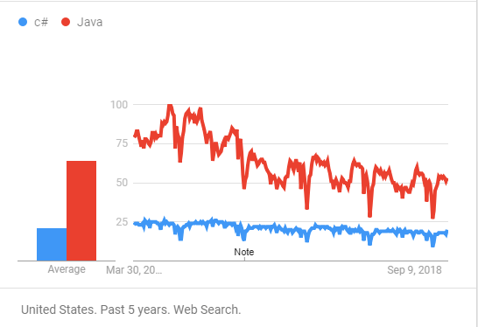

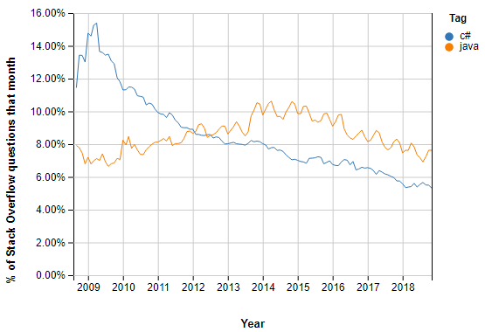

# Database Management

When Choose a Database management System, needed to find which is the best one according to the requirements. And considered about MySQL because its free and open source and less Resource Consuming. When Searching about My SQL, found these advantages of using MySQL.

1. MySQL is a Relational Database Management System or RDBMS which means storing and presenting data in a table format, arranged in rows and columns.
2. MySQL is highly secure as it contains a solid layer of data protection to protect sensitive data from intruders and passwords on encrypted MySQL.
3. MySQL is available for free to download and use on the official MySQL site.
4. MySQL is compatible with many applications, including Windows, Linux, NetWare, Novell, Solaris and other UNIX models.
5. MySQL provides a client and server application on the same computer or on different computers, via the Internet or local network.
6. MySQL has a unique architecture that makes it fast, cheap and very reliable.
7. MySQL provides developers with high productivity through ideas, triggers and stored processes
8. MySQL is simple and easy to use. You can create and interact with MySQL with only basic MySQL information and a few simple SQL statements.
9. MySQL has a client-server architecture. It can be any number of clients or applications that connect to a database server (MySQL) to query data, save changes, etc.
10. MySQL can measure and manage more than 50 million lines. This is sufficient to handle almost any amount of data. Although the default file size limit is 4GB but it can be increased to 8TB.
11. MySQL allows transactions to be reversed.
12. MySQL is highly flexible as it supports a large number of embedded applications.

Then Compared it with Microsoft database solution called SQL Server.

|  |  |
| --- | --- |
| MS SQL Server | MySQL |
| Developed by Microsoft. | Developed by Oracle. |
| Limited third-party Support because of closed Source | **Easy of Use and large number of third-party apps to database handling** |
| Expects a large amount of operational storage space. | Expects less amount of operational storage space. |
| It enables for stopping query execution. | It doesn’t allow query cancellation mid-way in the process. |
| Doesn’t block the database while backing up the data. | Blocks the database while backing up the data. |
| It is not free. | **It is open source. It is freely available.** |
| It is a highly secured and doesn’t allow any kind of database file manipulation while running. | It allows database file manipulation while running. |
| It is available in multiple editions, such as Enterprise, Standard, Web, Workgroup, or Express. | It is available in MySQL Standard Edition, MySQL Enterprise Edition, and MySQL Cluster Grade Edition |

**Since MySQL platform is free and almost enough to handle POS system database operations, MySQL selected as Database Management System.**

# User Interface

After Choose Java as the Programing language, Developer has two options to Build user interface with Swing Controllers or traditional AWT Controllers. But there are many other alternatives frameworks to out there. Among there are several platforms, I selected the JavaFX platform to build clean and attractive user interfaces. As an advantage used Scene Builder to build JavaFX interfaces

# Other tools Used

1. Eclipse Used as Development IDE
2. Microsoft Visio Used to Draw Diagrams
3. WAMP Server used to Access MySQL Database through PhpMyAdmin
4. MS Office Word used to Documentation.

# User Interface Design

## Login Interface

There is an authentication process just before let Users to access the pos system. It used to prevent unauthorized access and gives permissions to access required features according to uses privileges.

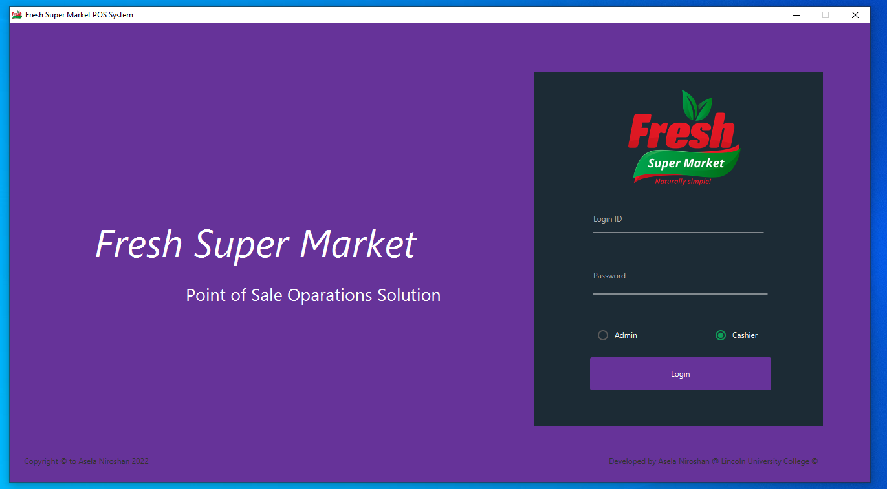

## Cashier Panel

When a cashier logged in to the system this is the default panel he or she can find. In the left side table contains all the product item available in the supermarket.

By typing or scanning product barcode, cashier can find customer bought products. Additionally, cashier can find the required product by typing product name too.

New button will create new bill for new customer and when add the customer bought items those will be added to the right-side panel. And real-time update the bill amount. After entering items Customer can create bill and after paid it will update the database.

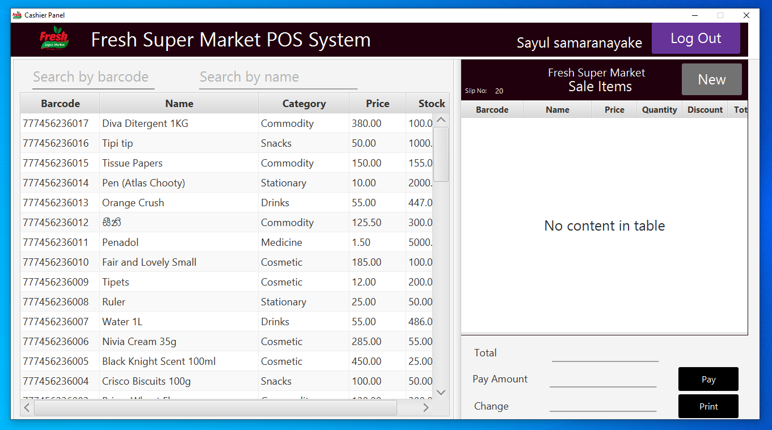

## Admin Panel

When a user logged as an Admin, he can perform all of admin tasks and those are listed top of the panel. When User click the item of panel, required JavaFX panel will be loaded to the main admin panel. Then admin user can perform relevant tasks.

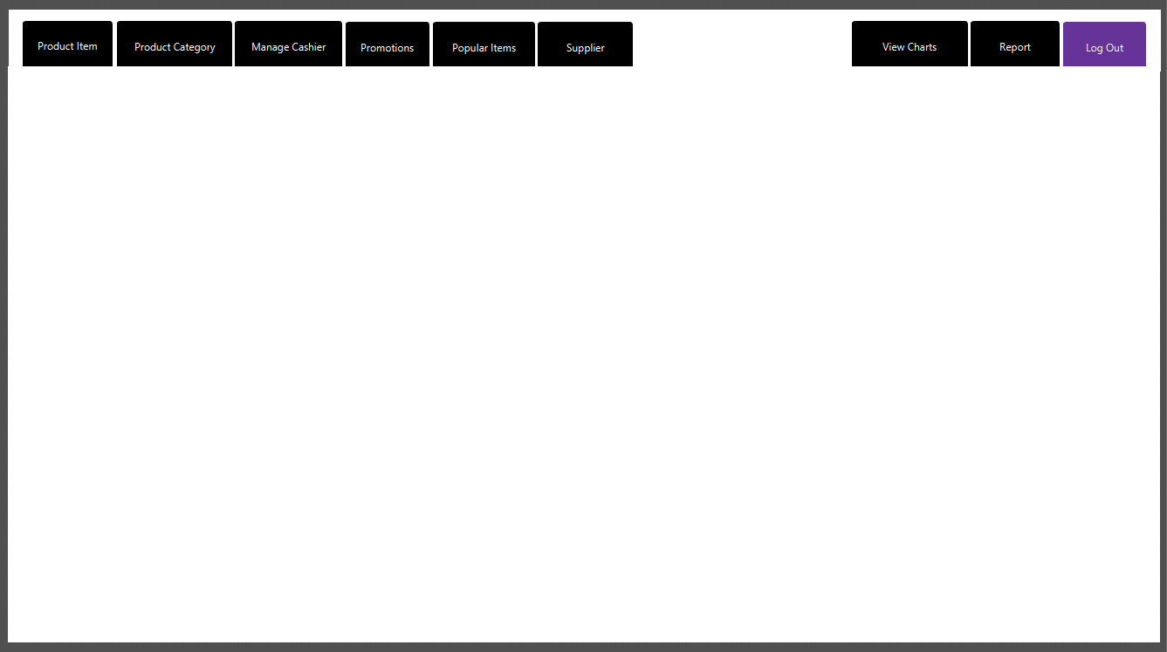

## Product Items

Product items is the default page to be loaded to the main admin panel when beginning. In This frame, privileges user must have to

1. Add New sell items and its description to the system such as name, supplier, Price and stock amount.
2. Update item price, category and stock amount.
3. Delete unnecessary product items from the system
4. Find and Filter items by its barcode or product name

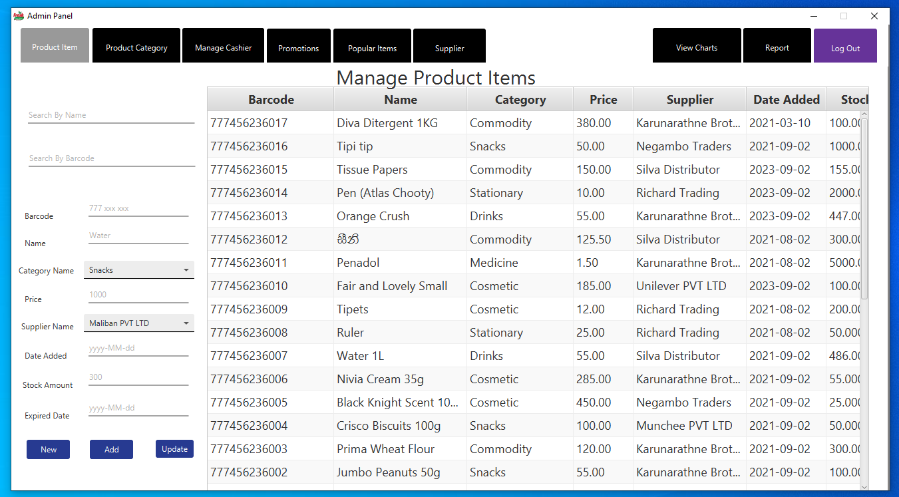

## Product Category

Admin can create product categories for manage and easily organized to products. It will be support to generate summarized reports for analyses the sales by categories.

In this panel it supports to create, update and Delete Categories too.

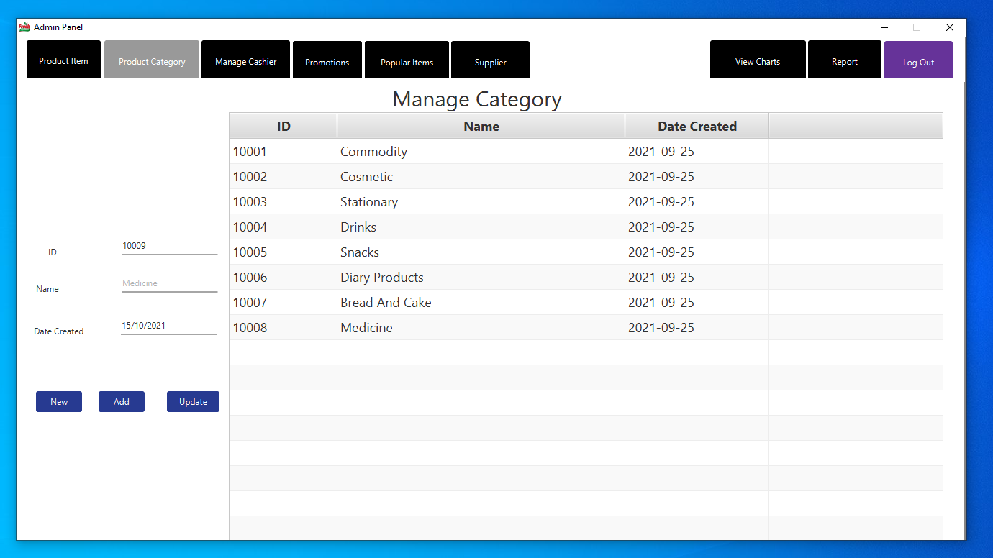

## Manage Cashiers

Admin can Manage Cashier employees. He can create cashier users and setup their passwords and update their details. After creating cashier and assigned password, relevant cashier can log into system as a cashier and can perform POS operations. As usual This panel also support CRUD operations for Cashiers

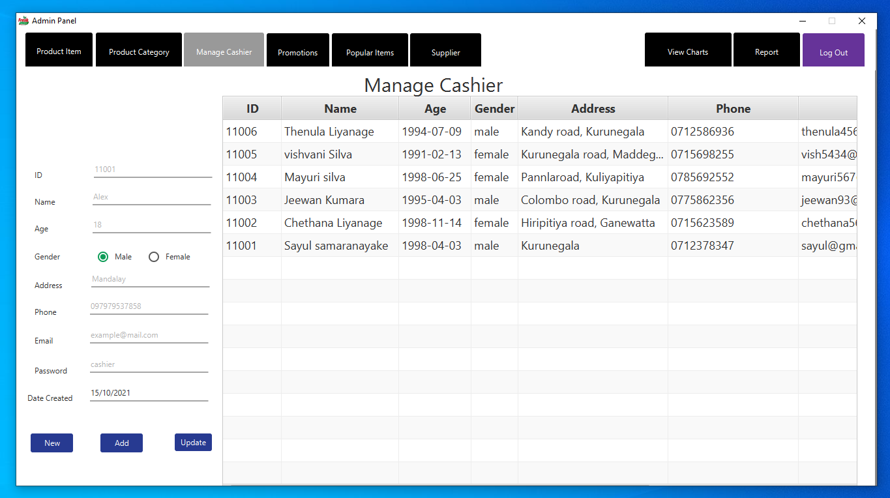

## Promotional Discounts

Admin can declare discounts for a certain product. He must mention the percentage of discount and then in POS operation it will be displayed the amount of discount for relevant product.

Admin Can perform CRUD operations as require in here too.

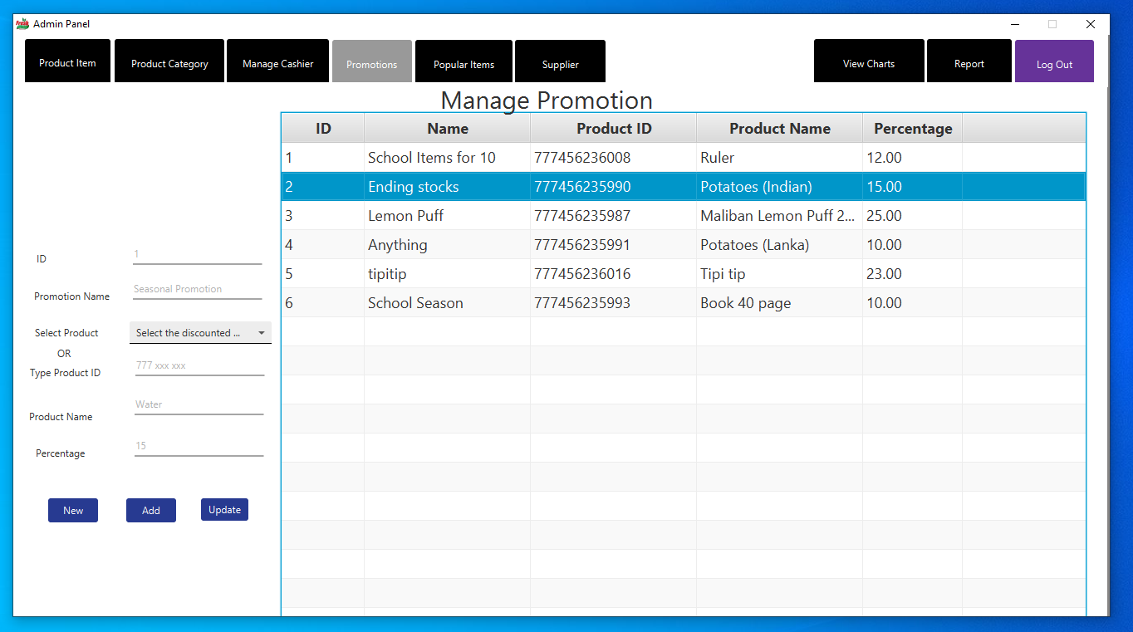

## Popular items

According to the frequency of buying products, popular items table will be sorted. So, it will display what are the popular products among the customer within supermarket.

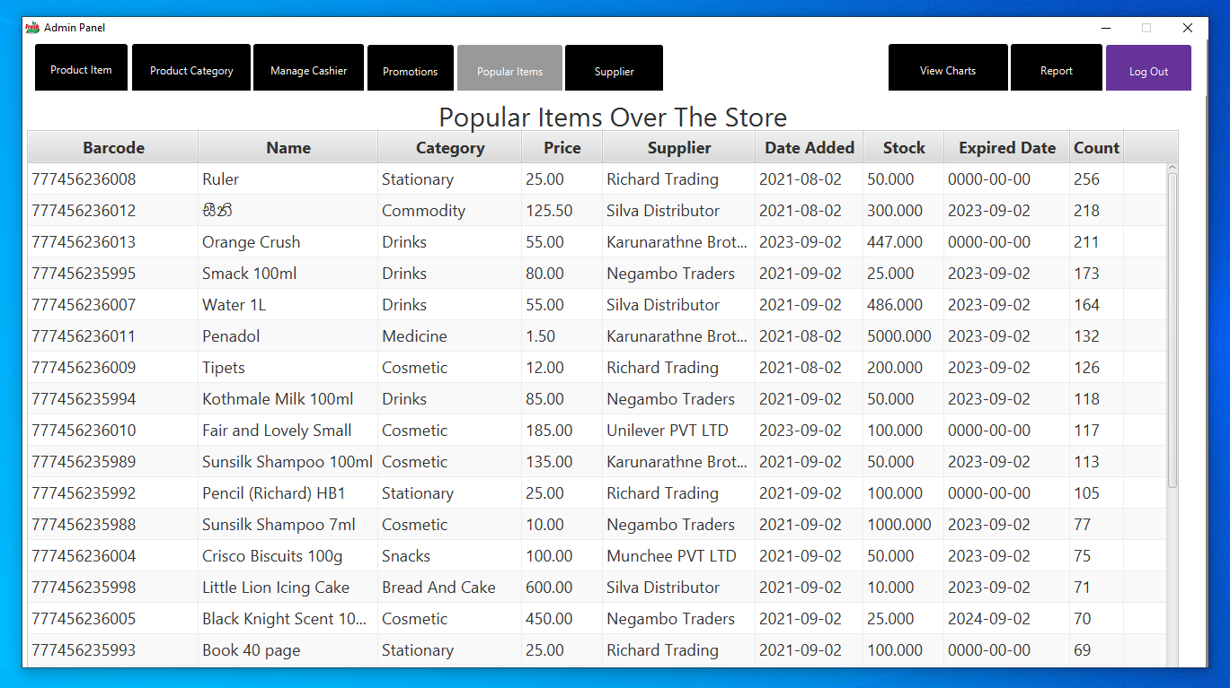

## Supplier Management

In the Supplier table Admin can manage supplier and change their contacts. Since the POS system is not perform specialized Inventory management, Admin can perform limited inventory management operations within this system.

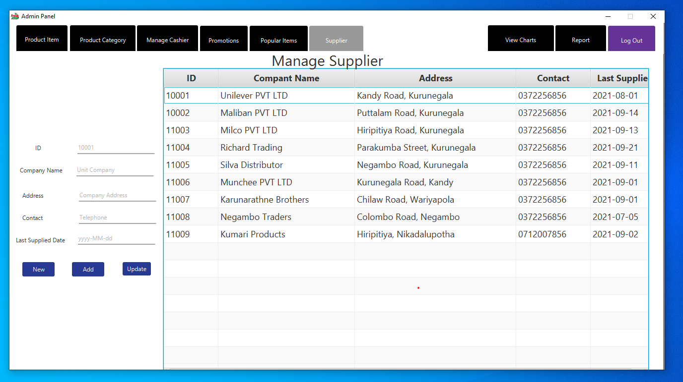

## Bill Issuing

After payments Customer can obtain detail bill with bought items. It shows Item name 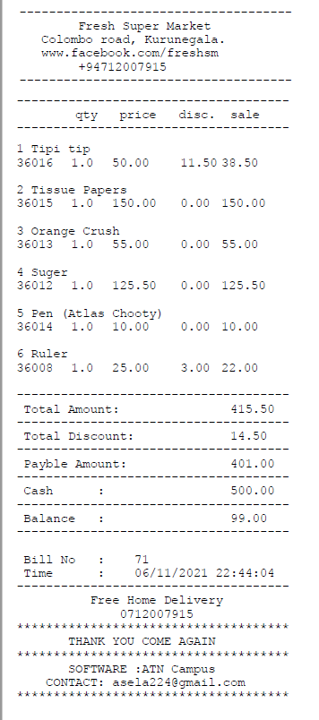 , barcode (product it), qty, each price, discount and price separately and total amount, total discount and payable amount at the bottom.

# Implementation

# User Input Validation

After Design the User interfaces, then started the Analyzed System implementation. in implementation process had to consider error and exception free clean system. So had to pay more attention to validation user inputs to feed database without issues. So declared data validation process just before Operations to make sure, User has gone through right path with following current procedures.

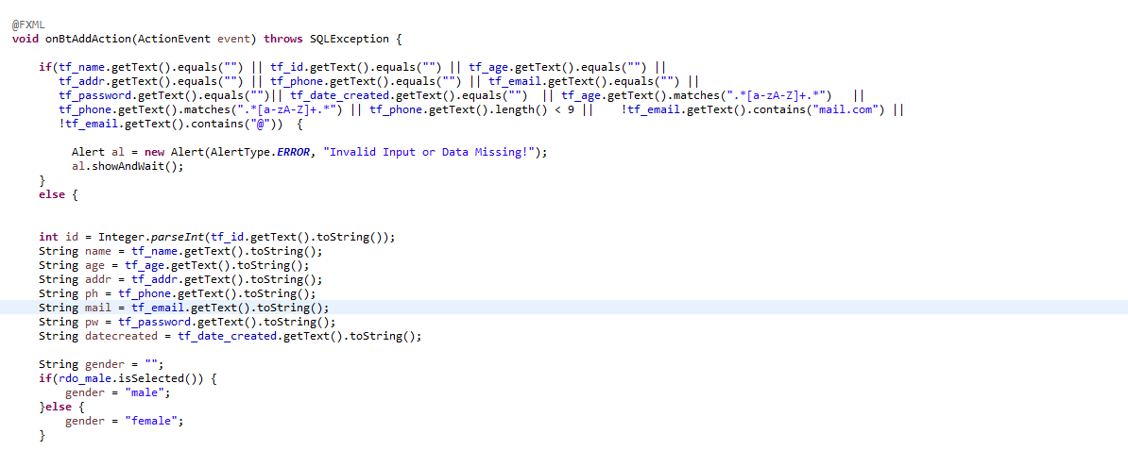

# Human Friendly Coding

Coding process is not limited to just run the program well. It has written for understand easily for developers too. It was very helpful to detect errors and failures and make fix those easily as well. Has used many comments like almost code blocks has defined with its requirement and how it works.

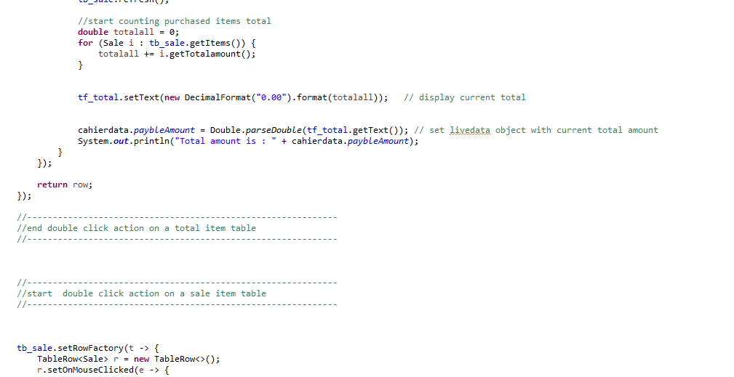

# IDE console as Log viewer

When point of sale solution running on GUI mode, system has used IDE console as a log viewer. It has displays current states, variable values and user responses as well. It helped to detect cause and fix those, when throwing exception because of coding mistakes or response handling mistakes.

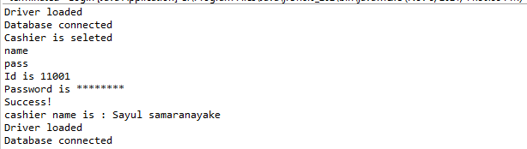

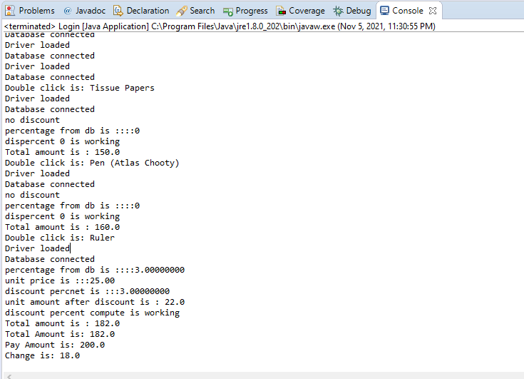

# Encapsulation

It has used java encapsulation techniques when creating Model objects to store data. So declare variables as private and implemented getters and setters to access variable data. Constructor also overloaded to initialize objects in just created.

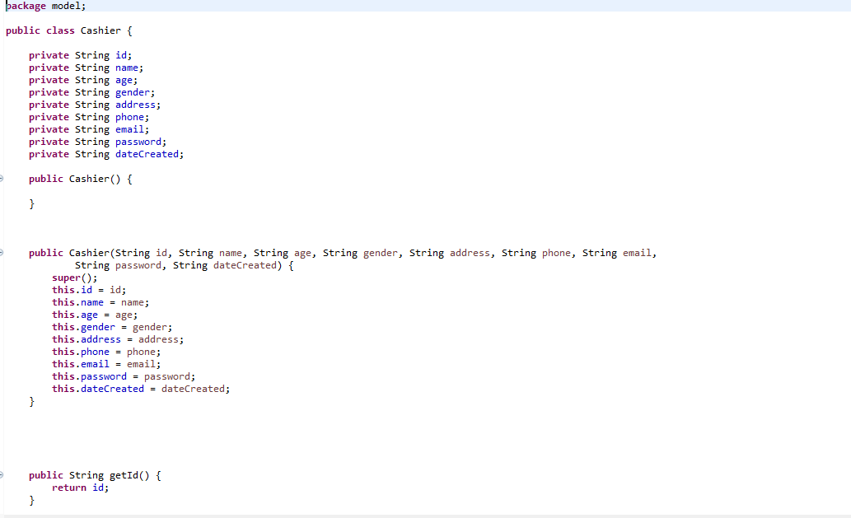

# Change Variable Types

In the Database model forced to used relevant data types to store data. But in the system, it has to change the type as required. When require to data represent in text Fields, its needs to convert them as Strings. When need to do calculation, those are converted to numeric types. And also when execute database query, it need to convert as relevant variable types

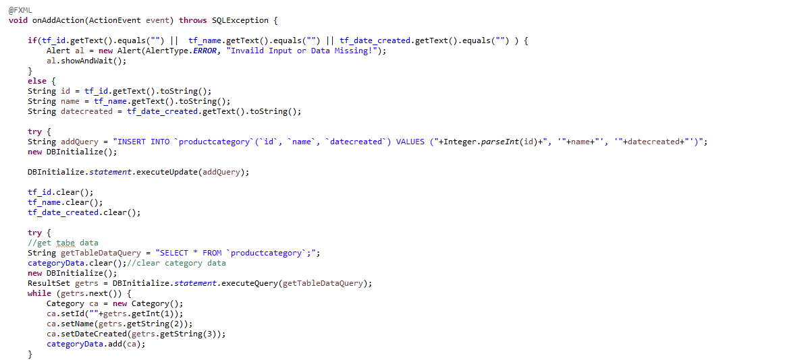

# Testing

# Testing Methodology

Software testing is the execution of the software by intention of finding software bugs. By doing good software testing software can be a bugs free or minor bugs System. Software testing can be categorized in many parts. Software testing can be done in the time of development and later as a separate testing process.

# White Box Testing

Testing is being done while development and coding is done. Errors will be identified at the moment where development happens and fixed them at the same time. This is very effective way and defects can be fixed without going to the Testing phase. It is a method of testing software that tests internal structures and working of an application.

# Black Box Testing

Testing which will be done by examines the functionality of an application without monitoring the internal structures of the system. This testing will be done without looking at internal code structure, implement details and knowledge of internal paths.

# User Acceptance Testing

Testing which will be done by the user. User will give feedback about the system after done testing by the user. So, the things which they are mentioning and errors need to be fixed after the user Acceptance testing.

# Usability Testing

To get what are the actual needs and to get an idea how user will interact with system one of the methods can be used is Questioners can. By giving some set of simple questions with answers to choose able to identify the way how user expected the system should behave and what type of computer knowledge they have. And also, what kind of people are going to interact with the system. Following is a part of Questioner used for the Point-of-Sale system.

# Testing Login View

|  |  |  |  |
| --- | --- | --- | --- |
| Test Scenario | Test cases | Status (Pass/o  n hold/Fail) | Comments |
| Test Login View and its Basic Functions | Test case 1: Check password not display when typing | Pass |  |
| Test Case 2: Check user must enter valid user name and password as well as the role for login | Pass |  |
| Test Case 3: Check Load relevant views according to the user role when logged in | Pass |  |
|  | Test Case 4: Check invalid login credentials are not accepting and gives an error | Pass |  |

# Testing POS Operations

|  |  |  |  |
| --- | --- | --- | --- |
| Test Scenario | Test cases | Status (Pass/o  n hold/Fail) | Comments |
| Test POS View, operations and its Functions | Test case 1: Check item tables has loaded product items correctly | Pass |  |
| Test Case 2: Check barcode and Item name search filter works correctly | Pass |  |
| Test Case 3: Check cashier name displayed in top right corner | Pass |  |
| Test Case 4: Check next slip number displayed top of the sale item table | Pass |  |
| Test Case 5: Check selected items added to sale item table | Pass |  |
| Test Case 6: Check display each price, quantity, discount and price correctly | Pass |  |
| Test Case 7: Check cashier can change quantity and then update price according to quantity | Fail | When Update Quantity Discount percentage changing  (Fixed) |
| Test Case 8: Check Total amount displays correctly | Pass |  |
| Test Case 9: Check Display balance if available when input paid amount and hit enter | Pass |  |
|  | Test Case 10: Check Display balance if available when input paid amount and hit enter | Pass |  |
|  | Test Case 11: Check update inventory and sale records when press pay button | Pass |  |
|  | Test Case 12: Prompt to print the bill when press print | Pass |  |

# Test Issuing Bill to Customers

|  |  |  |  |
| --- | --- | --- | --- |
| Test Scenario | Test cases | Status (Pass/o  n hold/Fail) | Comments |
| Test Bill Attributes | Test case 1: Check Store name and contact displayed on top of the Bill | Pass |  |
| Test Case 2: Check item name barcode quantity, sale price separately in a row | Pass |  |
| Test Case 3: Check bill shows total amount, total discount and payable amount correctly | Pass |  |
| Test Case 4: Check that bill number and date time displayed at bottom | Pass |  |

# Testing Product item view

|  |  |  |  |
| --- | --- | --- | --- |
| Test Scenario | Test cases | Status (Pass/o  n hold/Fail) | Comments |
| Test Add product items validations | Test case 1: Check system can return valid next barcode to add new item when press new Button | Pass |  |
| Test Case 2: Check system  Can’t add new Item without name, category, price, supplier | Pass |  |
| Test Case 3: Check system can add new Product successfully | Pass |  |
| Test Basic Functions of the product page | Test Case 4: Check barcode / product id Number | Pass |  |
| Test Case 5: Check prices has two decimals even update the table | Pass |  |
| Test Case 6: Check Search filters are working | Pass |  |
| Test Case 7: Check update and Delete Options are working | Pass |  |

# Testing Product Category View

|  |  |  |  |
| --- | --- | --- | --- |
| Test Scenario | Test cases | Status (Pass/o  n hold/Fail) | Comments |
| Test Add product Category validations | Test case 1: Check system can return valid category id to add new category when press new Button | Pass |  |
| Test Case 2: Check system  Can’t add new Item without name and current day shows as added date | Pass |  |
| Test Case 3: Check system can add new Product Category successfully | Pass |  |
| Test Basic functions of the product category page | Test Case 4: Check barcode / product id Number | Pass |  |
| Test Case 5: Check update and Delete Options are working | Pass |  |

# Testing Employee View

|  |  |  |  |
| --- | --- | --- | --- |
| Test Scenario | Test cases | Status (Pass/o  n hold/Fail) | Comments |
| Test Add employee validations | Test case 1: Check system can return valid next employee id to add new employee when press new Button | Pass |  |
| Test Case 2: Check system  Can’t add new Item without name, address, password and phone number | Pass |  |
| Test Case 3: Check system can add new employee successfully | Pass |  |
| Test Basic Functions of the employee page | Test Case 4: Check update and Delete Options are working | Pass |  |

# Testing Promotional Discount View

|  |  |  |  |
| --- | --- | --- | --- |
| Test Scenario | Test cases | Status (Pass/o  n hold/Fail) | Comments |
| Test Add Discount validations | Test case 1: Check system can return valid next promotion id to add new promotion when press new Button | Pass |  |
| Test Case 2: Check system  Can’t add new promotion without name, product and percentage | Pass |  |
| Test Case 3: Check product combo box shows all the available products | Pass |  |
| Test Case 4: Check system can add new discount successfully | Pass |  |
| Test Basic Functions of the discount page | Test Case 5: Check update and Delete Options are working | Pass |  |

# Testing Supplier View

|  |  |  |  |
| --- | --- | --- | --- |
| Test Scenario | Test cases | Status (Pass/o  n hold/Fail) | Comments |
| Test Add Supplier validations | Test case 1: Check system can return valid next supplier id to add new supplier when press new Button | Pass |  |
| Test Case 2: Check system  Can’t add new Supplier without company name, address and contact number | Pass |  |
| Test Case 4: Check system can add new Supplier successfully | Pass |  |
| Test Basic Functions of the Supplier page | Test Case 5: Check update and Delete Options are working | Pass |  |

# Collecting Customer Feedback

## 1. User Acceptance

User Acceptance is a very important factor in software development. It is the last phase of software testing. Actual users of the system test the system to make sure it can handle required functionalities well. If the users are satisfied with the system the software development is done.

Below is a form of user Acceptance used and the results. It has two parts to gather User Acceptance level of Overall System and each section.

**Point Of Sale system**

**Fresh Supermarket**

Part I

1. How many experiences you have as an employee?
   * 1. Less than 2 years
     2. Greater than 2 years
     3. Greater than 5 years
2. Your knowledge about handling computer Software
   * 1. Basic
     2. Average
     3. Advance
3. Your Knowledge about Payroll system
   * 1. Basic
     2. Average
     3. Advance
4. How much user Friendly the POS system Software
   * 1. Bad
     2. Good
     3. Excellent
5. Is the System is satisfied with your needs
   * 1. Yes
     2. No
6. Need to do modifications to this system.
   * 1. Yes
     2. No

(If needed please mentions your suggestions on No10 at the Part 2 )

Part II

|  |  |
| --- | --- |
| Gathering User Reviews  POS system for Fresh Supermarket | |
| 01 | How are the user Interfaces looks in the system?   1. Poor 2. Average 3. Good 4. Very Good 5. Excellent   Suggestions: |
| 02 | How easy to create new Bill and add items to the Bill?   1. Poor 2. Average 3. Good 4. Very Good 5. Excellent   Suggestions: |
| 03 | Bought item list loaded in to sell Table   1. Poor 2. Average 3. Good 4. Very Good 5. Excellent   Suggestions: |
| 04 | Item list loaded in to Item table   1. Poor 2. Average 3. Good 4. Very Good 5. Excellent   Suggestions: |
| 05 | Showing details in generated Bill   1. Poor 2. Average 3. Good 4. Very Good 5. Excellent   Suggestions: |
| 06 | How easy to view, add, remove, update product items?   1. Poor 2. Average 3. Good 4. Very Good 5. Excellent   Suggestions: |
| 07 | How easy to view, add, remove, update product Categories?   1. Poor 2. Average 3. Good 4. Very Good 5. Excellent   Suggestions: |
| 08 | How easy to view, add, remove, update Promotional Discounts?  1.Poor 2. Average 3. Good 4. Very Good 5. Excellent  Suggestions: |
| 09 | How easy to view, add, remove, update Supplier?  1.Poor 2. Average 3. Good 4. Very Good 5. Excellent  Suggestions: |
| 10 | Which areas must be Developed further? |

# Future Upgrades

There are lot of areas to be updated in later versions. Since the Project had to be completed in limited time Period, System has developed with essential sections. Those have mentioned below.

# Security

Fresh Super market Point of Sale System need to be updated in Security essentials. Sensitive data such as Employee Personal data has stored as plain text. Anyone has accessed the Database server can retrieve that data or alter as well. Hope to store data as cyphertext instead plain text in future versions.

So currently system database not used to store high privileges users such as Manager and Admin. Those login data have stored in a Variable. After implement cryptography those sensitive data can be stored in Database as cyphertext.

# Log viewers

Even IDE console used as a demo log viewer it can’t b used in real environment. Its can available only for developers. So Hope to Implement log file in later versions to Check system behaviors an get troubleshooting tips when system failure.

# Reports & Charts

Hopefully designed areas to implements additional decision-making support reports and charts to visualize company states.

# What I Have Learnt

Before complete this kind of project, I was thinking Coding/implement part is the harder part in a software development as well as System Analyzing. But End of this project I have got a little experience how to actual project works.

So, I figured out Implementation part is not so hard, If We have a Proper analyzed system to Develop. And Why We must allocate reasonable time period to analyses the System.

Then Keep everything in a Document is easier than keep everything is in mind.

I had to learn about following technologies to complete this project

1. Java FX
2. MVC Architecture

Then I have improved my skill in following areas

1. Flat UI User Interface Design
2. JDBC Connectivity Exceptions
3. Database Concepts and MySQL
4. Easy to read and understand Coding to Programmers /Developers